**白盒：流程图数封闭范围**

**环复杂度的计算**：就是有几个分支要走

方法1：有几个块+1

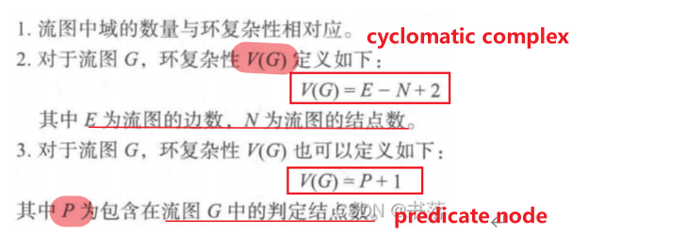

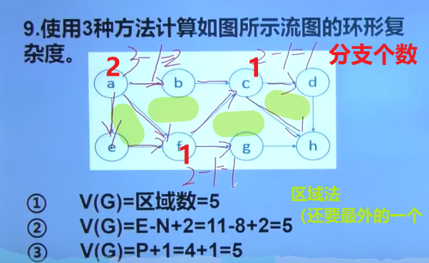

基本路径：比如

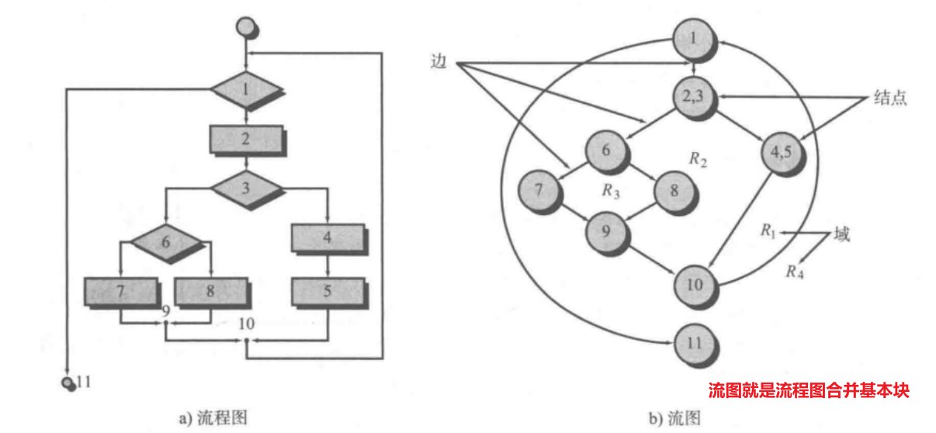

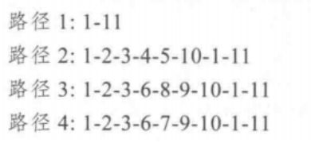

**黑盒：等价类划分和边界值划分**

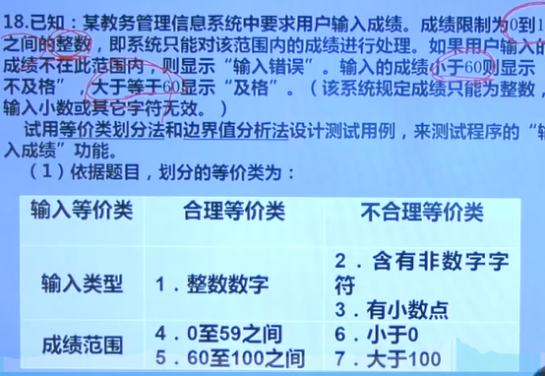

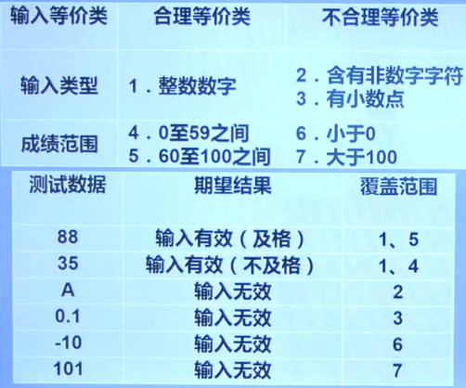

边界值分析法：边界值±1

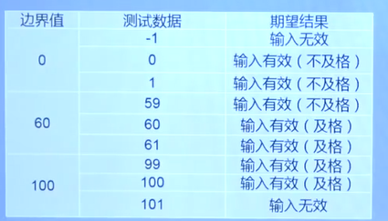



[2023&2022期末]

首先是等价类分析，输入类型，然后和positive不等价的是0或负数；和0<N<500不等价的是0或者>=500

那么就要分别给出N=0、N>=500、N合理但是序列的值=0或是负数、N合理序列的值也合理这几种

然后是边界分析，给出N=-1，0、1、499、500、501，里面的序列的值是-1、0、1的情况

**LOC**

LOC 每行代码多少钱

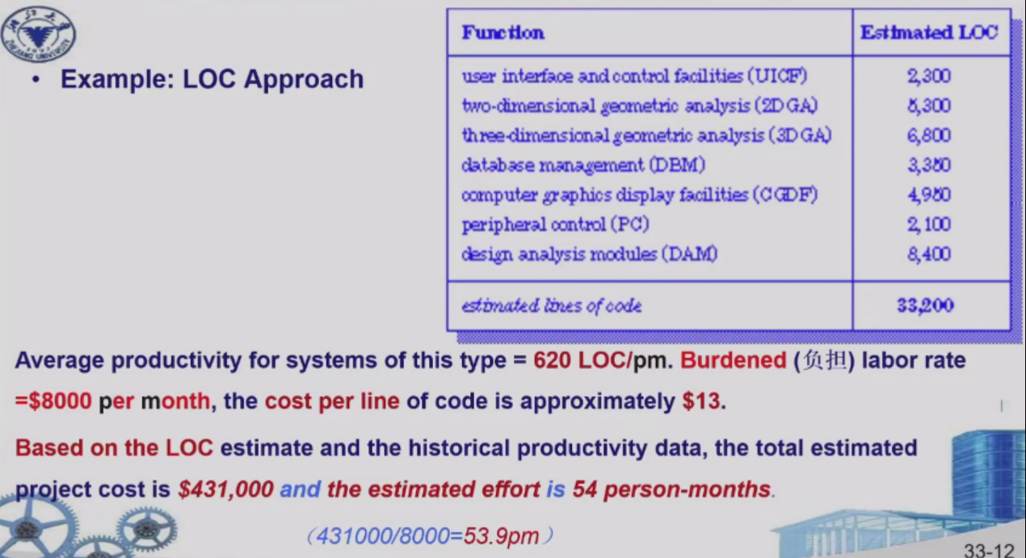

Fp函数点个数

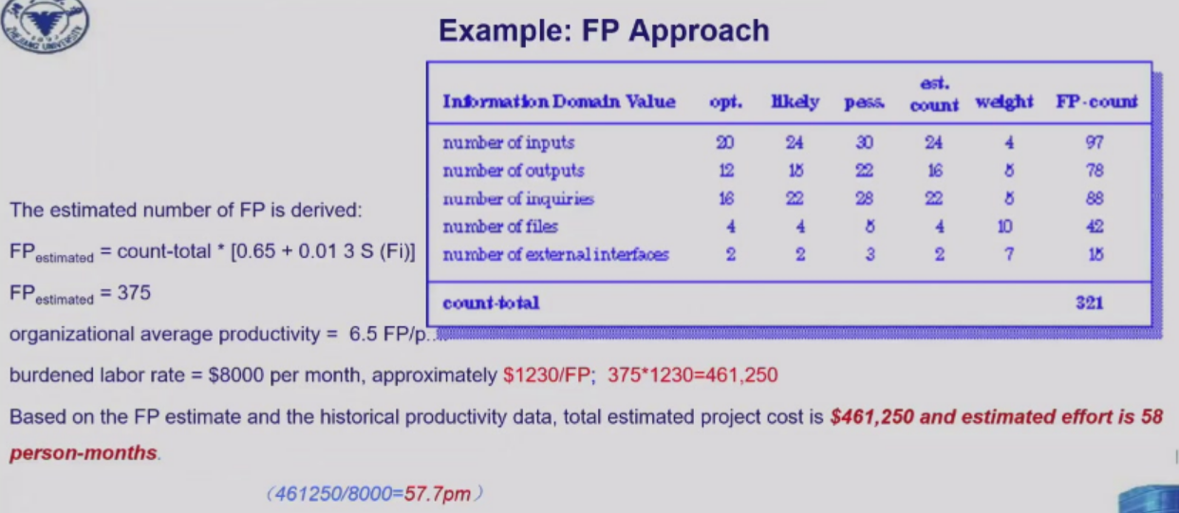

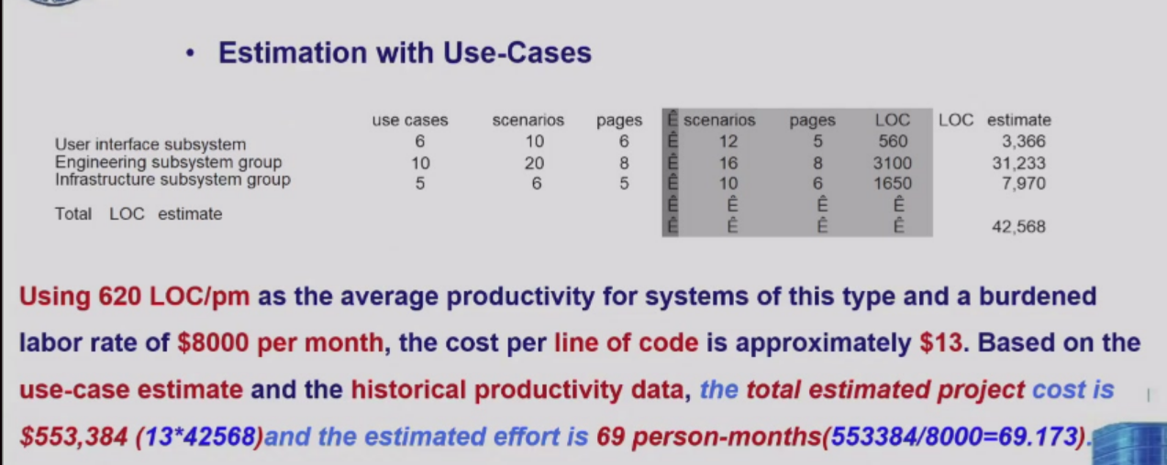

[quiz3] There are two conventional estimation methods: LOC (lines of code) approach and FP (function point) approach. Suppose the burdened labor rate =$8000 per month. For a type of software project, the average productivity is 625 LOC person-month (i.e. LOC/pm) and 6.4 FP/pm, respectively, and the total estimated lines of code are 35000 and 370FP, respectively. Please answer following questions.

**(1) What are the costs of per LOC and per FP? In term of person-months (pm), what are the total estimated project cost by above two estimation methods, respectively?**

35000/625*8000

370/6.4*8000

1. **Why do FP-based metrics have advantages over LOC-based metrics in some aspects?**

**独立于语言之外，在设计完成之前就可以完成计算**

FP关注**功能性**

反应用户需求

允许基准和比较

支持估算和生产力度量

**FP依赖于information domain value， LOC依赖于software functions**

**Use-Case Diagram**

哪些角色参与，哪些功能，第三方系统工具

左角色，中间功能，右第三方（存储啥的）

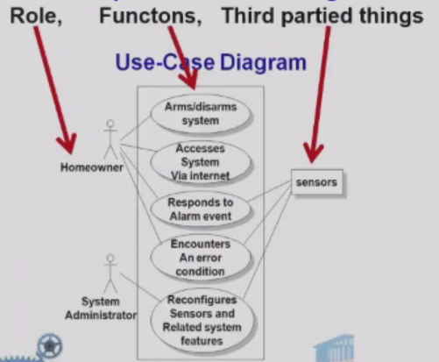

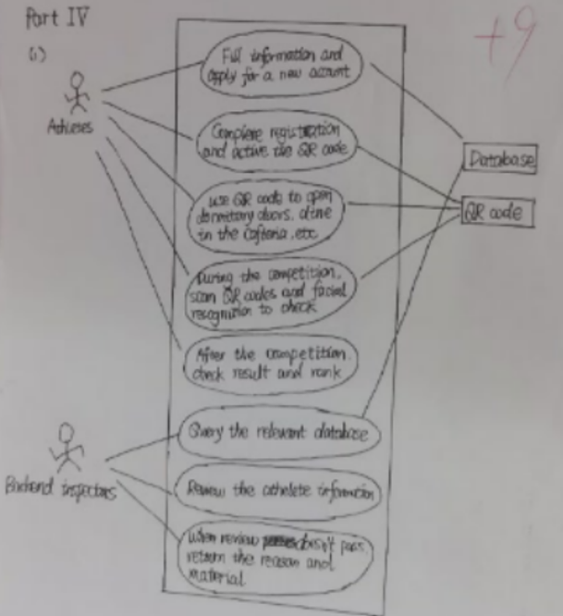

**CRC card**

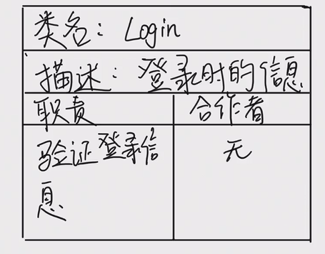

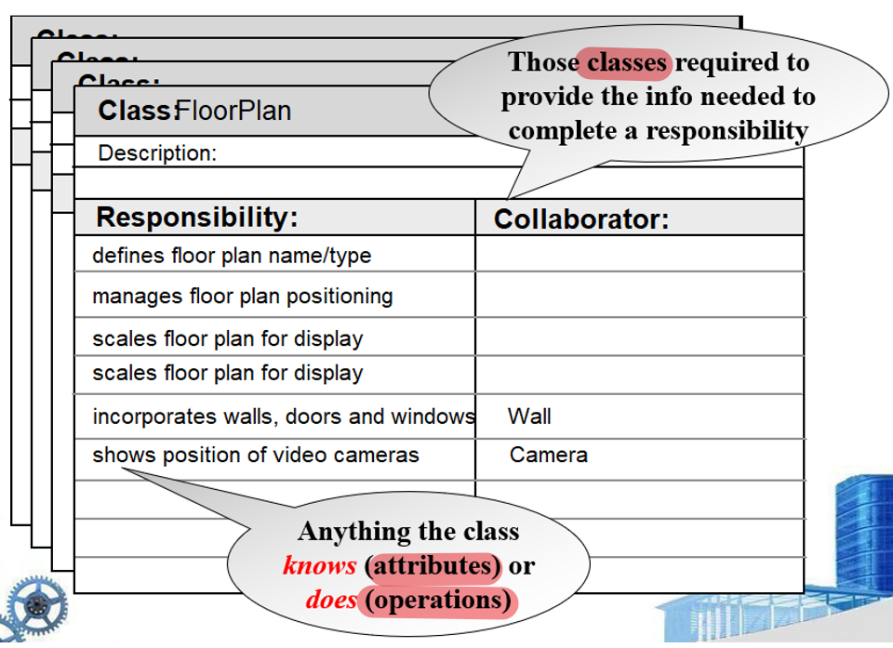

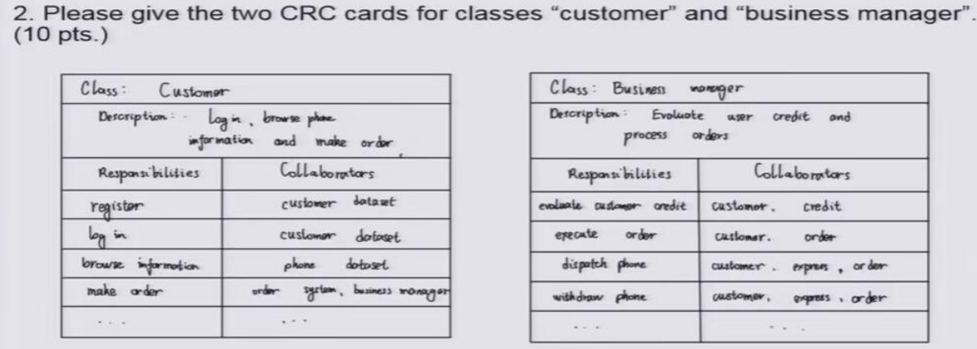

**类图**

类名，属性，操作

类名在它的命名空间中唯一。类名以大写字母开头，省略多个单词之间的空格。

属性和操作在类的范围内必须无二义。属性和操作是以小写字母开头，后续单词的首字母大写，且同样省略空格。

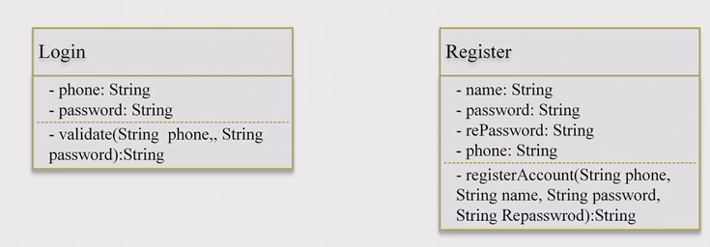

如果类图进一步能展现类之间的关系就会变成下面的这样

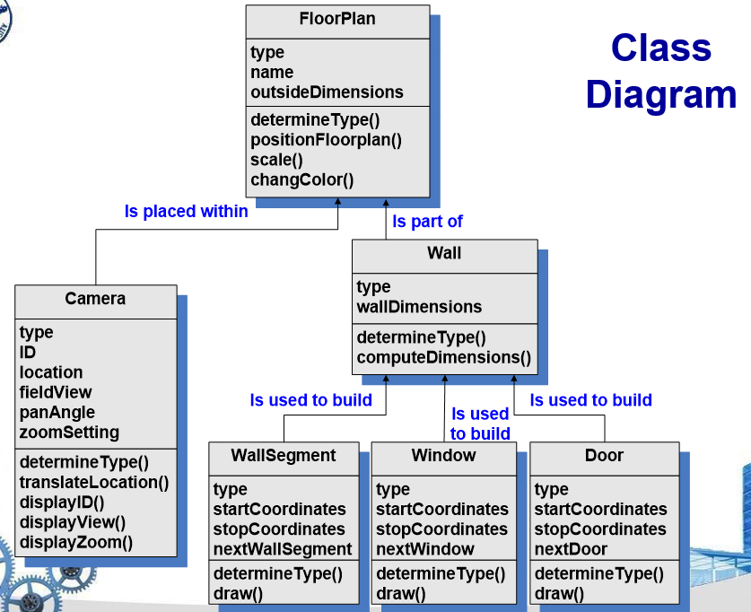

箭头是普通的关联箭头

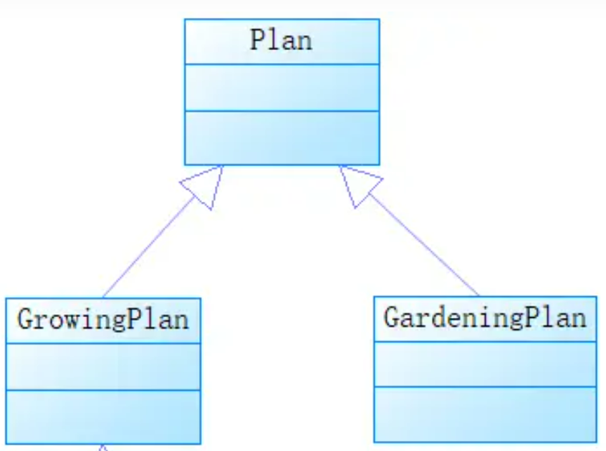继承

**状态图 state digram**

状态图和活动图几乎一样，除了圆角框内是状态（名词）还是活动（活动一般是动名词）的差别

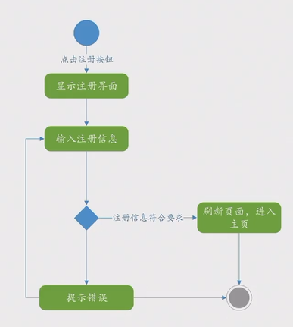

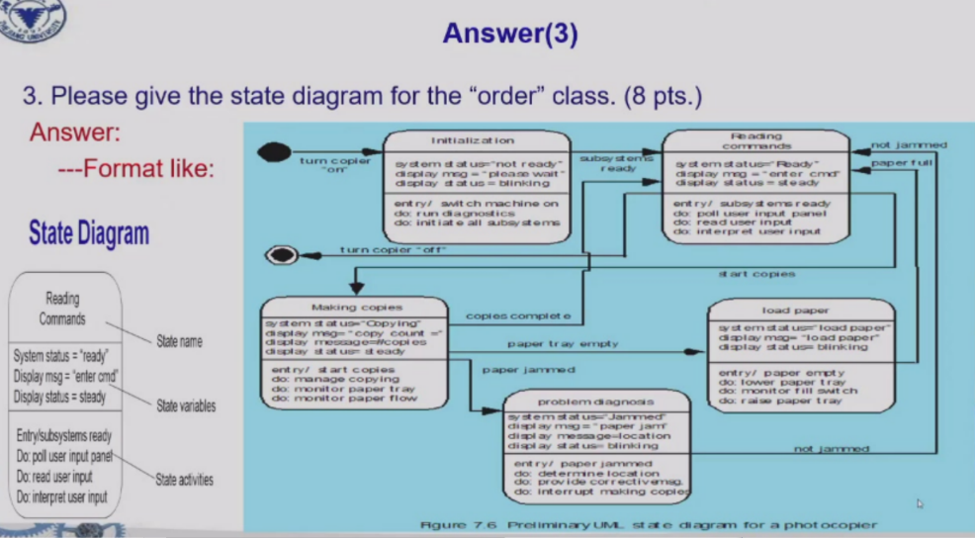

泳道图是活动图的一种有用的变形，进行了并列分割

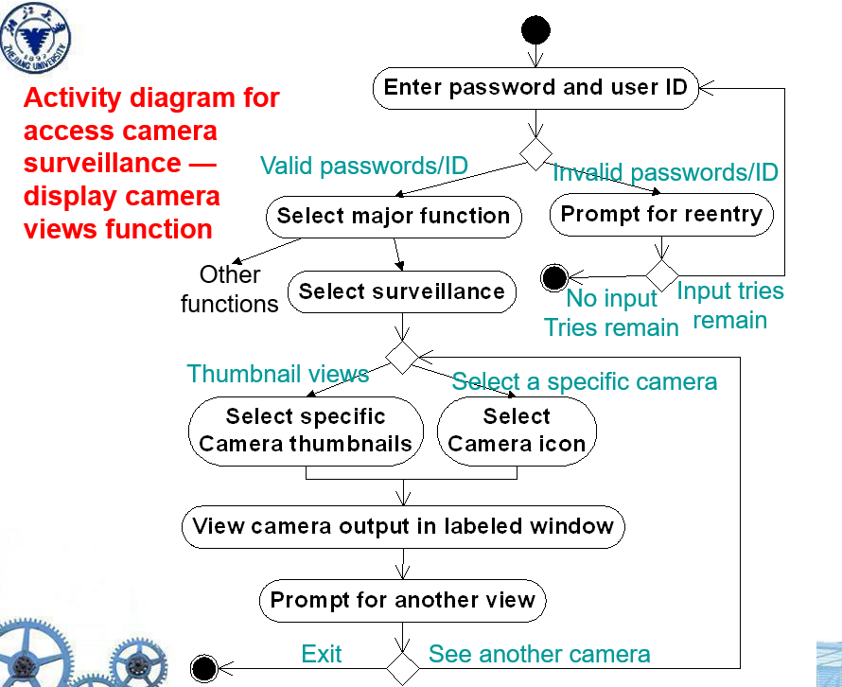

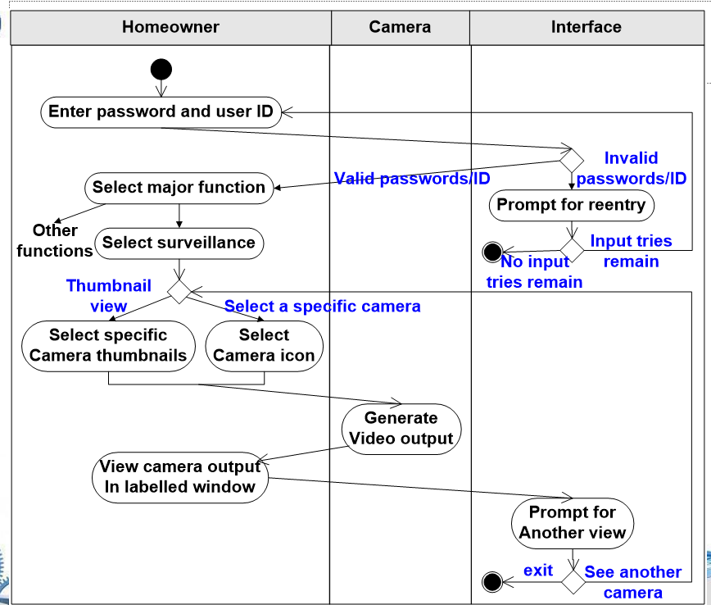

**时序图**

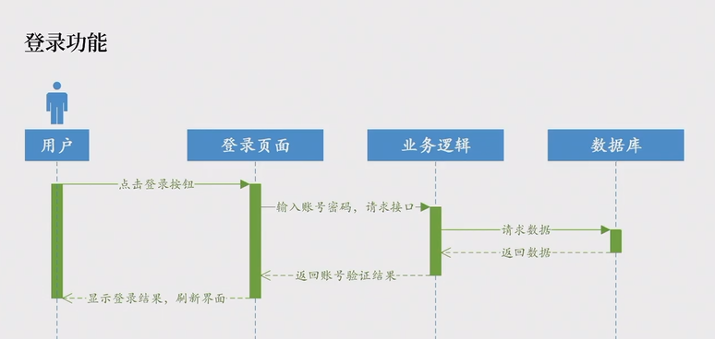

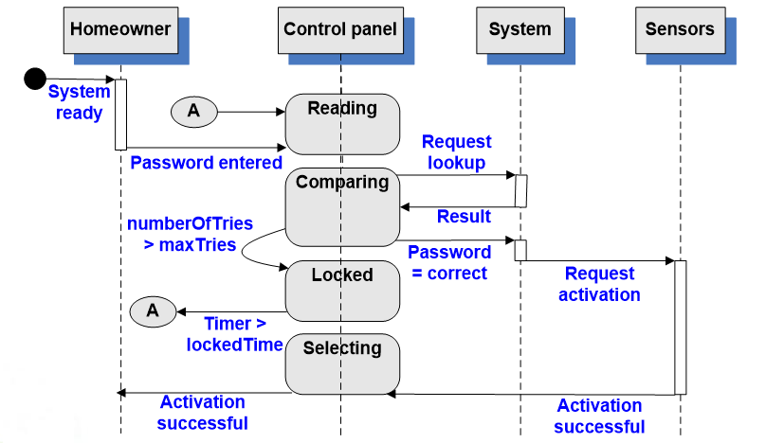

**数据流图 dataflow**

方框是起点终点，圆角矩形是加工（一般是动作，由动词名词组成），箭头是数据流。数据存储（包括零时文件，就是下面那个3条线的

先确定起点终点，然后确定存储

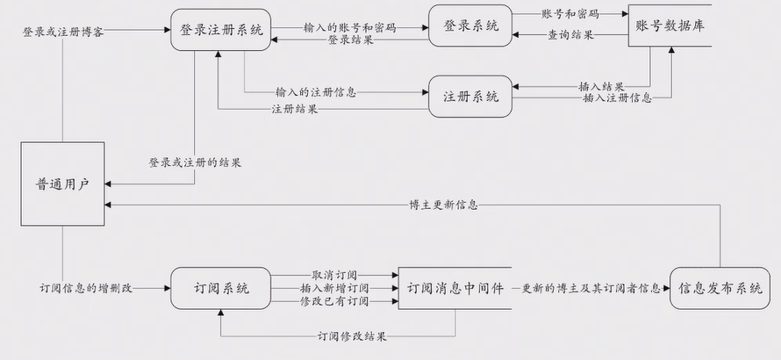

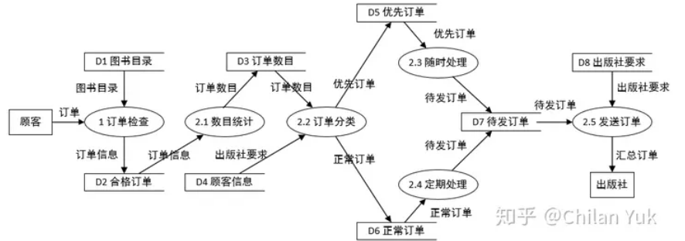

**Software architecture**

前后端分离，有哪些表，哪些数据库

下例展示的项目叫GCSP

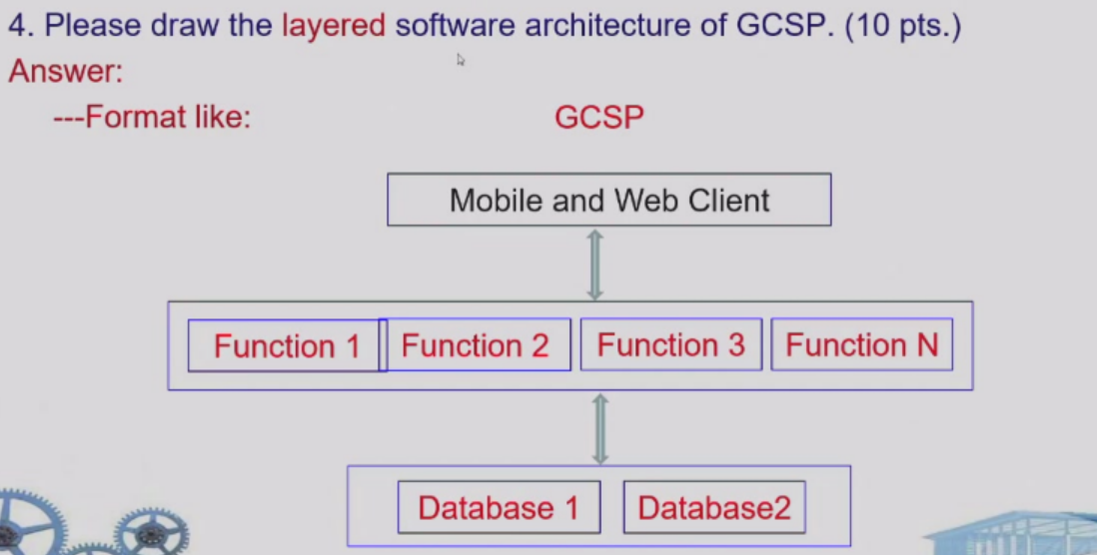

这个也是layered

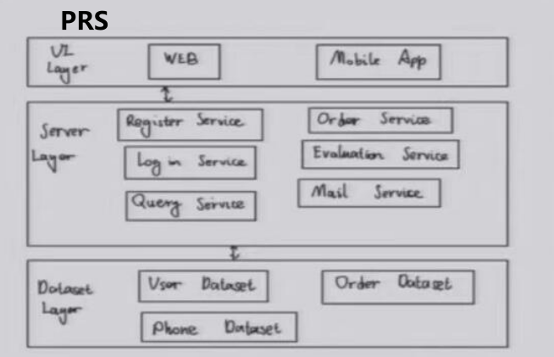

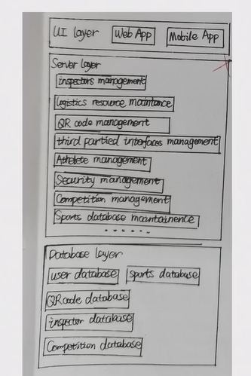

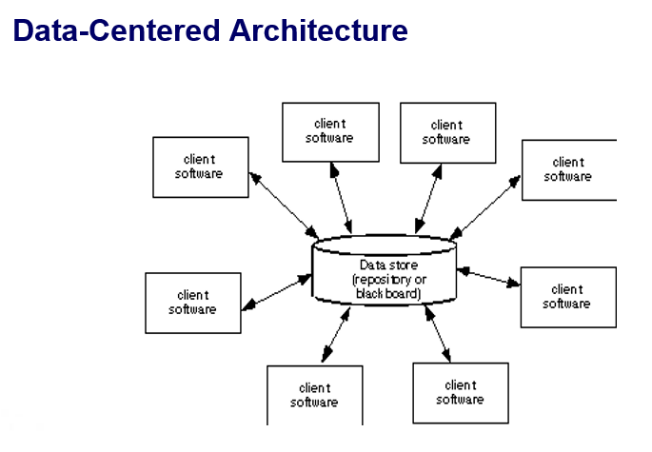

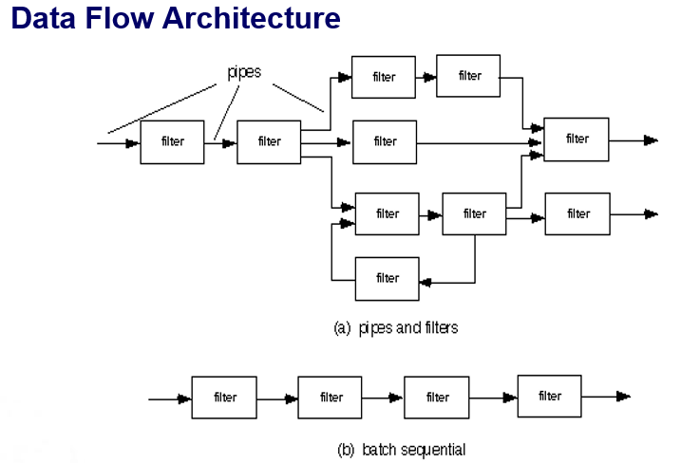

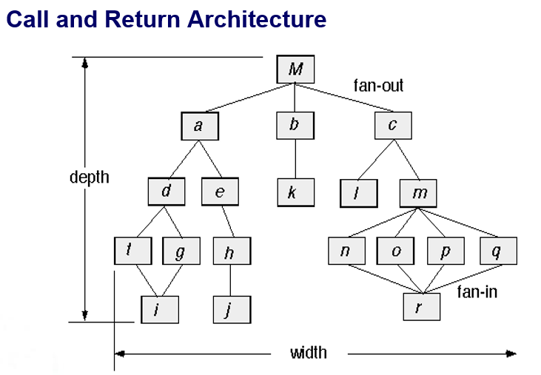

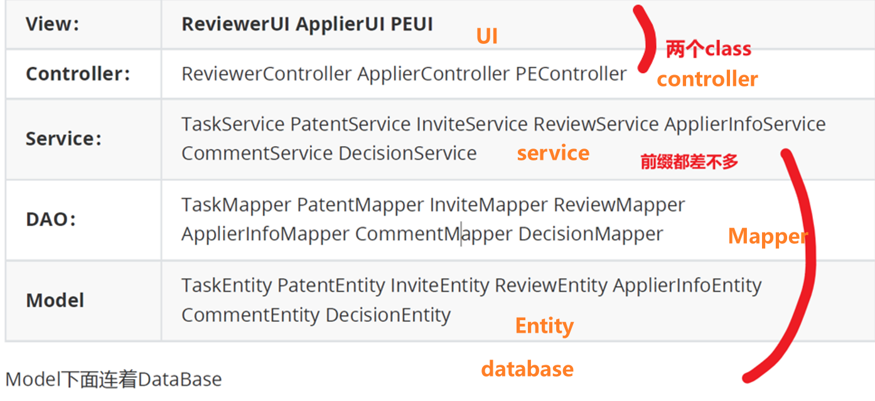

**测试策略**

**接导单内集，回配性安认，αβ黑白压**，安恢压性部

- 单元测试

- 边界测试是最重要的单元测试任务之一

- 集成测试，主要测试接口

- 回归测试

- 冒烟测试

- 确认测试

- α测试：α测试测试是由代表性的最终用户在开发者的场所进行。软件在自然的环境下使用，开发者站在用户的后面观看，并记录错误和使用问题。α测试在受控的环境下测试。

- β测试：β测试在一个或多个最终用户场所进行。与α测试不同，开发者通常不在场，因此，β测试是在不为开发者控制的环境下软件的“现场”应用。是在不可控的环境下测试。

- 客户验收测试

- **系统测试**：验证系统成分已经正确地集成在一起，并且完成了指派的功能。

➢ 恢复测试：通过各种方式强制让软件以各种方式失败并验证恢复是否正确执行。

安全测试：安全测试验证建立在系统内的保护机制是否能够实际保护系统不受非法入侵。

压力测试：压力测试的目的是是软件面对非正常的情形。是一种要求以非正常数量、频率或容量的方式进行彻底评估。

性能测试：性能测试用来测试软件在集成环境中的运行性能。

部署测试：有时也将部署测试称为配置测试，是在软件将要在其中运行的每一种环境中测试软件。

- 白盒测试：也称为玻璃盒测试，是一种测试用例设计方法，它利用作为构件层设计的一部分描述的控制结构来生成测试用例。（根据源代码来测试）。循环测试是白盒测试

- 黑盒测试：作为发现其他类型错误的辅助方法。边界值和等价类

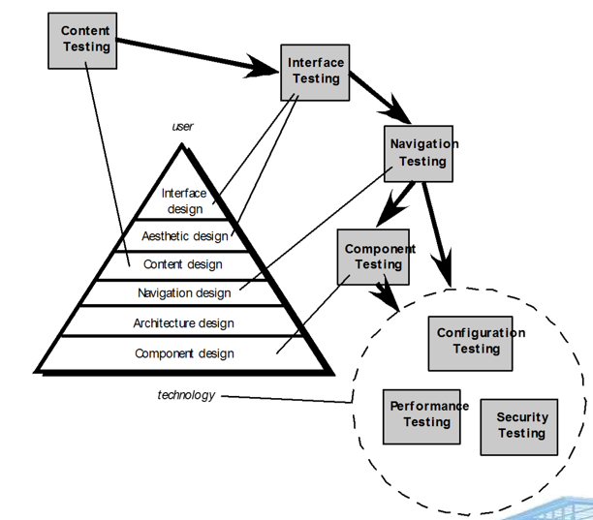

**其他的问答**

[wzy quiz2] Scrum例会——Serum 团队每天召开的短会(一般情况为15分钟)，会上所有成员要回答三个问题:

1. 上次例会后做了什么?
2. 遇到了什么困难?
3. 下次例会前计划做些什么

[wzy quiz1] Compared with the Prescriptive process, what are the advantage and disadvantage of Agile process,敏捷操作 respectively?

优点：开发周期短，随时应对需求变化

缺点：需要团队的高效协作、沟通，不适用于人数规模大的开发团队，需要与客户频繁沟通协作

[2022原题] Reengineering paradiag的六个阶段

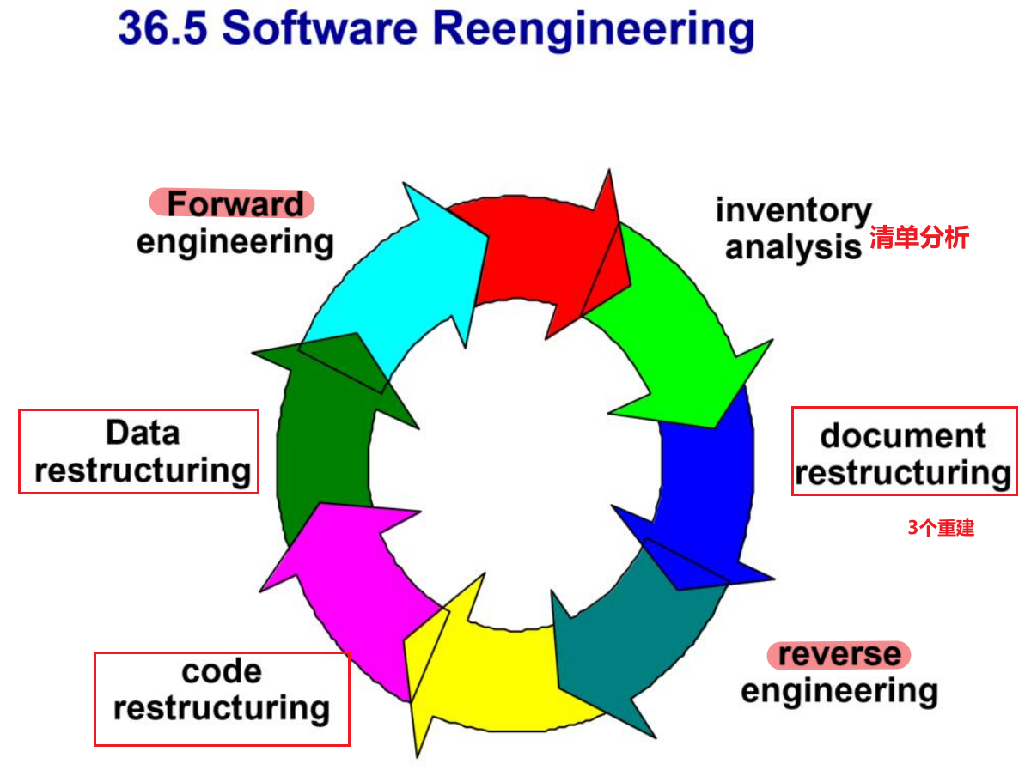

[2022原题] 美学设计要考虑哪些因素

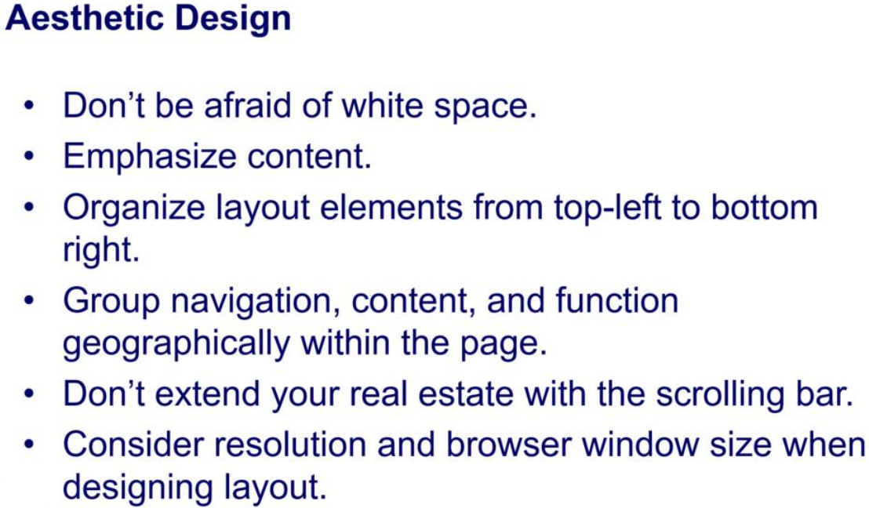

[wzy quiz3&quiz4] 利益相关者For the software projects, a series of stakeholders are involved. Please list at least three types of stakeholders and give a brief explanation for them.

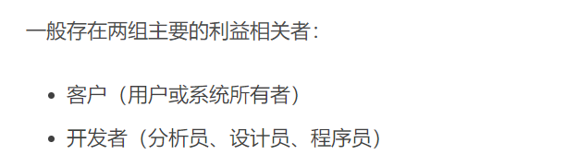

Stakeholder即利益相关者，指与软件项目相关的任何人或组织，包括用户、客户、开发人员、测试人员、项目经理、法律顾问、审计员、监管机构等

[wzy quiz1] (1)What are the three golden rules of UI design? (2) The shortcut for copy is defined as “Ctrl +C”, and why is the shortcut for paste is defined as “Ctrl +V” rather than “Ctrl +P”?

1. Place the user in control; Reduce the user’s memory load; Make the interface consistent
2. V距离C近，而且V也可以解释为Viscidity

[2020] Why does software need to evolve over time? (6pts)

适应新计算科技的需求；增强新的商业要求；和现代的数据库和系统等结合；更适应网络环境结构

[quiz1] Please take our course project as an example to explain what are Normal, Expected, and Exciting requirements for QFD (Quality Function Deployment)?

**Normal requirements** are written in the project requirements to meet the requirements of Party A’s software requirements, such as building beautiful museum model, etc

**Expected requirements** are not written in the project requirements, but as a mature software engineering should achieve software requirements, such as smooth running, software security, etc.

**Exciting requirements** are requirements that are not written into the project requirements, that are not anticipated, that do not affect the functionality of the program, but that can greatly enhance the user experience by having them, such as particularly fine museum and collection modeling

[quiz2] What does the **Rules of** **Thumb**经验法则 emphasis? Why the level of abstraction should be relatively high?

The model should focus on requirements which are visible with in problem or business domain. 模型应关注问题或业务领域中可见的需求

Abstraction levels are high in thumb rule. 经验法则中的抽象级别较高

New elements added in the analysis model should help in better understanding of the software requirements of the system. 分析模型中添加的新元素应有助于更好地理解系统的软件需求

These elements provide better understanding of the functionality, behaviour and information domain of the system. 这些元素有助于更好地理解系统的功能、行为和信息领域

Coupling should be minimized throughout the system整个系统中的耦合应最小化

The model should be simple模型应该简单

The model should focus on requirements that are visible within the problem or business domain模型应关注问题或业务领域中可见的需求

[wzy quzi2 && 23原题] Formal technical review(FTR) is very important for uncovering software errors before the software is released to the end users since errors can be amplified in the latter steps if they cannot be found in the former phase, as shown in the following defect amplification models:

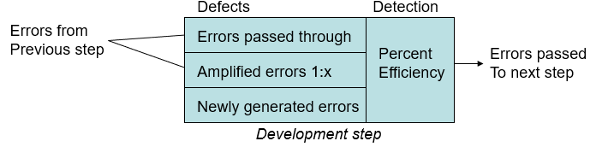

Suppose: (1) the newly generated errors are **20, 60, 60** for the preliminary design, detail design and code/unit test respectively; (2) the errors passing through and that whose being amplified **are the same平分** between preliminary and detail design and between detail design and code/unit test; (3) the value of x, which is also the same for detail design and code/unit test, is **3**.

If the values of percent efficiency for the whole process without FTR (Formal Technical Review) and with FTR are **0 and 50% respectively过滤掉50%**, please illustrate the defect amplification process for preliminary design, detail design and code/unit test, and calculate the final errors after code/unit test respectively.

without FTR: 260

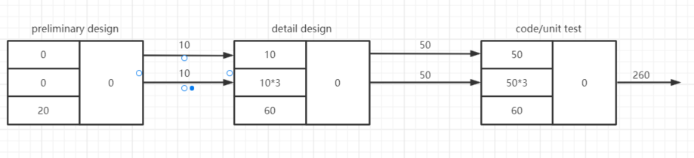

with FTR: 70

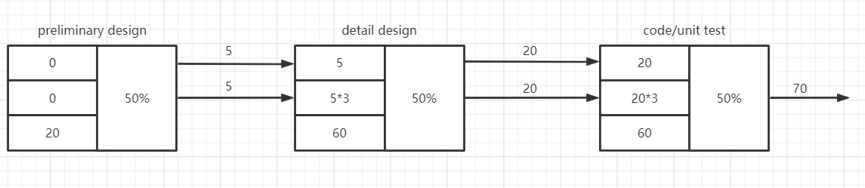

传递的是保留的错误，算cost用的是检测代价